Bright Custom Homes
Info@brightcustomhomes.ca
This questionnaire is designed to gather detailed insights into your lifestyle and design preferences, ensuring your custom home is tailored to your vision and functional needs.
Client Vision and Lifestyle
Questionnaire
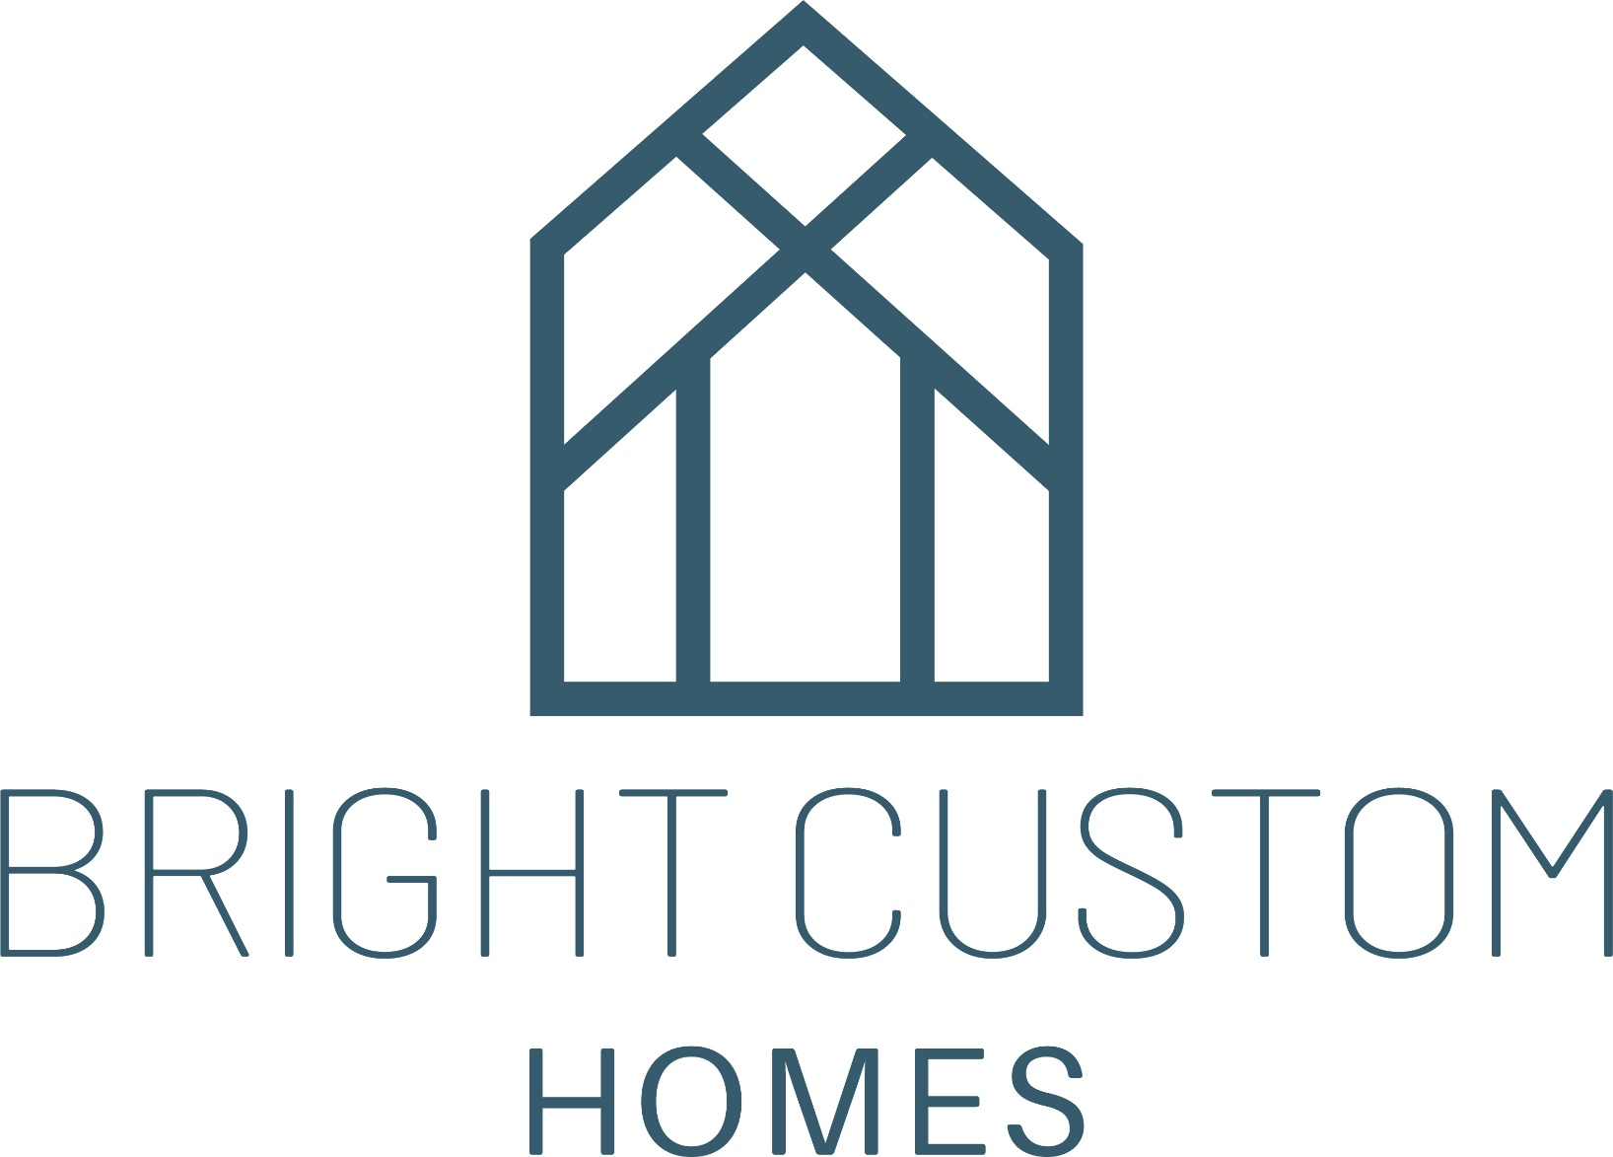

General/Overall Home Design
1. What architectural style(s) do you love (e.g., modern, traditional, contemporary, rustic)?
2. How many floors would you like your home to have?
3. Do you have any preferences for the overall layout (open concept vs. defined spaces)?
4. How many people will be living in the home full-time, and are there plans for future family growth?
5. Do you frequently entertain guests? If so, what types of gatherings do you host (formal dinners, casual parties, overnight stays)?
6. Are there any specific views or natural features on the property you’d like to highlight?
7. How important is privacy in your home layout (e.g., separation of public and private spaces)?
8. Do you have preferences for ceiling heights in various areas (e.g., vaulted ceilings in the living room)?
9. Would you like a dedicated foyer or entryway, and should it include features like storage for coats and shoes?
10. Are there any specific accessibility features you need (e.g., wider hallways, ramps, an elevator)?
11. Do you envision any special architectural details, such as exposed beams, statement walls, or built-in niches?
12. Are there any future needs we should consider, such as accommodating aging parents or the possibility of a home extension?

Kitchen
1. Do you want an open-concept kitchen that flows into other areas or a more separate space?
2. How often do you cook, and what type of cooking do you do (baking, gourmet, quick meals, etc.)?
3. Do you need a walk-in pantry? If so, how large should it be?
4. Would you like a kitchen island? If so, should it include seating, a sink, or a cooking range?
5. Are there any must-have kitchen appliances or features (e.g., double ovens, wine fridge, built-in coffee maker)?
6. How much counter space do you need, and do you prefer any specific material for countertops?
7. How important is having a meal prep space, like a butler’s pantry or a separate prep kitchen?
8. Should the kitchen include built-in features, like a breakfast nook, wine cellar, or a coffee bar?
9. Do you have preferences for appliance placement and layout (e.g., a specific work triangle arrangement)?
10. Would you like the kitchen to have easy access to outdoor dining or entertaining areas?

Dining Room
1. How many people do you need to seat comfortably in the dining area?
2. Do you prefer a formal, closed-off dining space or a more casual, open one?
3. Would you like built-in features like a buffet, shelving, or a bar area?
4. Should the dining room be easily accessible from the kitchen and/or outdoor spaces?
5. Are there any specific lighting preferences, like a chandelier or recessed lighting?
6. Do you have a vision for any particular materials or finishes in the dining room?

Living/Family Room
1. What activities will take place in the living room (e.g., TV watching, reading, socializing)?
2. Do you want built-in features like shelving, cabinetry, or a fireplace (gas, wood, or electric)?
3. How important is natural light in this space, and would you like large windows or skylights?
4. Should the living room have direct access to outdoor spaces like patios or decks?
5. Would you like a flexible design that can accommodate multiple activities, such as a play area or a study nook?

Bedrooms (Primary and Secondary)
1. How many bedrooms do you require, and what size should each be?
2. What features would you like in the primary bedroom (e.g., walk-in closet, sitting area, private balcony)?
3. Do you want an en-suite bathroom for every bedroom, or just select ones?
4. Are there any soundproofing requirements to ensure privacy in the bedrooms?
5. How important is natural light, and do you have specific window preferences?
6. Do you envision any built-in furniture, like custom shelving or wardrobes, in the bedrooms?

Bathrooms
1. How many bathrooms would you like, and which should have en-suites?
2. What is your vision for the primary bathroom (e.g., freestanding tub, double vanity, large walk-in shower)?
3. Do you prefer a separate water closet in the primary bathroom?
4. Are there any must-have features, like heated floors, a rain shower, or a steam shower?
5. What kind of storage would be ideal (e.g., built-in cabinets, linen closets, floating shelves)?
6. Do you have specific preferences for bathroom materials and finishes?

Home Office/Study
1. Do you need one or more home office spaces, and where should they be located?
2. Would you like built-in desks or bookshelves, or do you prefer a more flexible space?
3. How important is natural light and a view in your work area?
4. Should the office include any features for privacy, like soundproofing or strategic placement away from noisy areas?

Entertainment/Media Room
1. Do you want a dedicated media room, or should it be a more flexible entertainment space?
2. How many people do you want to accommodate comfortably in this area?
3. Should the room include soundproofing or acoustic panels for an optimal experience?
4. Do you have a preference for seating arrangements, like theater-style or more casual sofas?
5. Are there any built-in features you'd like, such as a wet bar or custom shelving for media storage?

Outdoor Spaces
1. What types of outdoor spaces do you envision (e.g., patio, deck, pool, garden, outdoor kitchen)?
2. How important is the connection between indoor and outdoor living areas (e.g., large sliding doors)?
3. Would you like any covered outdoor areas for shade or all-season use?
4. Are there any specific landscaping features you want, like a water feature, fire pit, or built-in seating?
5. Do you need designated spaces for recreational activities, like a sports court or a play area?

Basement/Additional Spaces
1. Would you like a finished basement, and what purpose should it serve (e.g., extra bedrooms, gym, storage)?
2. Should there be any specific rooms, like a wine cellar, home gym, or workshop?
3. Do you want large windows or a walk-out design to bring in more natural light?
4. Are there any special requirements for temperature control in basement areas?

Garage/Utility Spaces
1. How many cars should the garage accommodate, and do you need extra space for storage or a workshop?
2. Would you like any built-in storage solutions for tools, sports equipment, or seasonal items?
3. Should there be a mudroom connected to the garage, and what features should it include?
4. Do you have preferences for the location and design of laundry and utility spaces?

Thank you for taking the time to complete this questionnaire. Your answers will provide us with a clear understanding of your lifestyle, needs, and design preferences, allowing us to craft a custom home that perfectly reflects your vision. By sharing your priorities and inspirations, we can ensure every detail is thoughtfully planned to create your dream living space.

